IBHAC
Meeting Summary
2.22.19

Announcements
Elisa Orona: The Health Improvement Annual Forum is on April 18th, 2019 featuring a health care strategist from Canada and the event will take place at the Chaminade Resort and Spa, come and join us!
Stacey Palau: New Life is looking for a Medical Director for approximately 8-10 hours a week, so if you know anyone or have any contacts, please let me know.
Jen Hastings: The Nadherny/Calciano Symposium is taking place next Friday, March 1st, 2019 at the Cocoanut Grove that is focusing on opiates. We hope to see you all there.
Carol Williamson: NAMI is offering a Spanish-language Family-to-Family class starting April 22, 2019, from 6:30pm-8:30pm.

Meeting Purpose
The purpose of this meeting was to review charter goals and strategically plan for 2019.

Background and history
Shelly Barker, HIP Program Director, provided a brief overview of the history of HIP and IBHAC.
- IBHAC history
  - ACA & MH Parity Act 2008
  - BSCF Langer Study March 2015
  - Technical assistance to 4 safety net primary care organizations to expand BH services
- As HIP was looking into the next phase, from 2015-2017, Blue Shield of CA foundation funding in community our pivoted from “Innovations in the Safety Net” to “Behavioral Health Integration through Community Collaboration.”
- April 2015 was the first meeting that was really rooted in action and working towards improvement.
- From June 2015-December 2018 there have been 31 meetings, ~20 organizations per meetings, and an average of 30 attendees per meeting.
- Blue Shield requested a survey be administered to coalition participants to look at the health of the collaborative. Indicators that were assessed included degree of trust, transparency, clarity, degree to what we are trying to achieve, and our cumulative score was 3.89 and only of the 7-group cohort SLO scored higher with a 3.9
- Early on in the TA phase, HIP engaged consultants to develop a questionnaire to look at integration in the primary care settings. The questionnaire has been conducted for 5 years now, and there has been movement in the delivery of services and challenges such as staffing and space.
Holly Hughes, LCSW, HIP Consultant
- Presented various integration frameworks that would be useful to members
  - Principles of Effective Integrated Health Care via AIMS Center
  - Blue Shield-Advancing Behavioral Health Care
    - This document presents a lot of detail into broad concepts
  - SAMHSA-HRSA Center for Integrated Health Solutions
    - This tool assesses where you are in terms of integration
  - National Council for Community BH- The Four Quadrant Clinical Integration Model
    - A framework to assist and support in determining what resources are needed for BH and physical health risk/complexity
- Patient experience changes when we have robust integration. The no wrong door is helpful when people can easily access care (e.g., a warm handoff). We want there to be choice, autonomy, and access to be smooth.
- Behavioral health leaders will be side by side with medical leaders at all levels in our community
- These frameworks can support what you are doing:
  - Ways of assessing levels of integration and tells where you are in terms of integration (SAMHSA)
  - Physical health risk and BH risk demonstrates what should be happening in each quadrant.
- Review of IBHAC Charter Goals

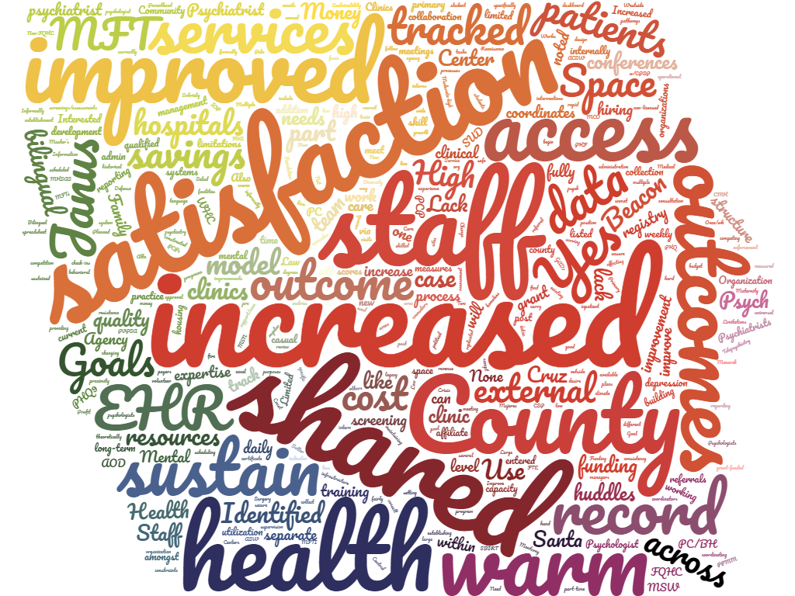
- Emily Solick: proposed the idea of a steering committee for IBHAC.

Group activity and discussion (see next page)

    - What topics do you want to focus on in 2019?

Share outcome data | Data sharing  and payer source | Re-entry/jail systems coordination | Opioid and meth use | Psychiatry for the uninsured
suicide prevention | Cross training | Continued relationship building | Child crisis care/youth services (collective vision) | SUD MAT Integration
Perinatal mental health | Finding licensed staff | Identify where people can go for behavioral/substance services rather than the Emergency Room | A roadmap for behavioral health | Child development screening and breaking the inter-generational cycle
Coordination, integration, and better collaboration for schools | Education for providers/line staff | Increased family support | Community education re-homeless | Utilizing skills/best practice of other organizations
Clear referral pathways | Prevention and early detection to reduce risk factors for family violence/opioids and perinatal | Best practices for seamless handoffs to BH | Case worker to keep client on pathway towards health | ACES  informed care

  - When you look at our IBHAC charter goals, discuss three action steps that can get us to the next level.

Longer appointment for better (improved) outcomes | More resources towards prevention | Evidence based screening and assessment | Patient experience surveying system-wide | Creation/expansion of braided funding programs
Moving needle towards data sharing | Advocacy for bilingual services | Sharing reimbursement for behavioral health across agencies | Invite speakers from different insurance programs | Learning about local resources-highlighting different agencies at meetings

Next Steps
The next IBHAC meeting is scheduled for March 22, 2019

Submitted by: Rita Hewitt, Program Coordinator

